What is Stack?

Stack is a data structure that stores items in A Last in First out manner. (LIFO)

Like a pile of books. Like a back button in our browser.

What are the stack operations?

1. Create Stack

We need to initialize an empty array or linked list.

1. Push

Inserting an element in the stack. Insert on the last element.

1. Pop

Removing an element from the stack. Removing from the last element

1. Peek

Shows the top element in the stack.

1. isEmpty

if the stack is full it return false.

1. isFull

if the stack is full in returns true

1. deleteStack

we can delete and entire stack from the memory.

Stack using Array:

1. Easy to implement.
2. Fixed Size

Stack using Linked List:

1. Variable size
2. Implementation is not easy.

Time and space complexity of stack using Array:

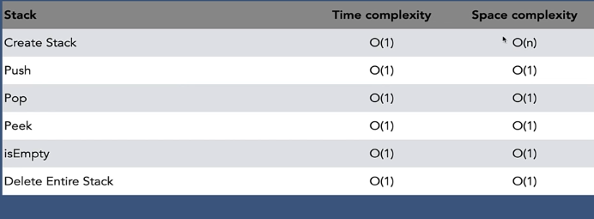

Time and space complexity of stack using Linked List:

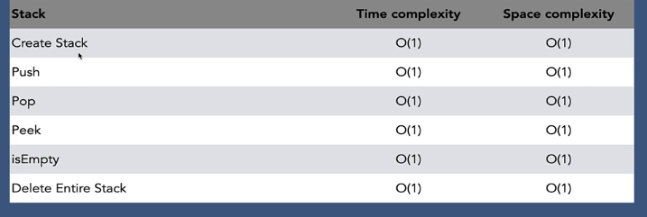

When to Use / Avoid Stack?

Use:

1. LIFO functionality
2. The chance of data corruption Is minimum.

Avoid:

1. Random access is not possible.